**Analog & Digital Electronics Project Report**

***On***

**Topic: Temperature Sensing Device.**



**Submitted by:**

**Name: Siddharth Singh**

**Roll no : 24**

**Sec : CSE 2B**

**TITLE**

**TEMPERATURE SENSING DEVICE**

**(FIRE ALARM).**

**INDEX**

|  |  |
| --- | --- |
| **Sl No.** | **Content** |
| **1.** | **ACKNOLEDGEMENT** |
| **2.** | **OBJECTIVE** |
| **3.** | **SCOPE OF THE PROJECT** |
| **4.** | **THEORETICAL BACKGROUND** |
| **5.** | **DESCRIPTION OF THE PRODUCT** |
| **6.** | **INPUT – OUTPUT VARIATIONS** |
| **7.** | **LIMITATIONS OF THE PROJECT** |
| **8.** | **CONCLUSION** |
| **9.** | **BIBLIOGRAPHY** |

**ACKNOWLEDGEMENT**

At the very outset, I take the privilege to convey my gratitude to those persons whose co-operation, suggestions and heartfelt support helped us to accomplish the project successfully. I take immense pleasure to express my sincere thanks and profound gratitude to my respected teacher for his continuous support, patience, motivation, enthusiasm, immense knowledge and providing timely support and suitable suggestions.

I want to thank my parents for their affection and their help for managing my life in busy times. Without them, it would have been very difficult to focus on my project.

My special thanks are to those who directly or indirectly extended their helping hands in making the project a grand success.

**OBJECTIVE**

To construct a temperature sensing device.

**Scope of Fire Alarm & Life Safety Support Program**

Contractor will Inspect, Test, Maintain, and Certify the fire alarm systems detailed on the “List of Equipment” below for the (OWNER LOCATION). The Contractor will satisfy requirements of the lasted edition of NFPA 72, Chapter 10, conform to the equipment manufactures recommendations, and verify operation of the fire alarm systems.

**Inspection**

A **visual inspection** of every device in the “List of Equipment” will be performed to ensure that no facility changes have occurred which could affect equipment or system performance based on the original design.

**Testing**

Every device and control function shown in the “List of Equipment” will be **physically activated** to ensure its functionality as designed and installed. Testing takes intoconsideration the AHJ (Authority Having Jurisdiction) requirements, local ambientconditions and the manufacturer’s recommendations. Contractor will follow NFPA 72recommended test methods and frequencies as a minimum guideline for system testing.System configuration is verified during quarterly inspections and compared to existing

records. Complete documentation of testing and a report of any deficiencies will be presented for review before the Technician leaves the facility. Audible Testing will be conducted during off or non-operational hours and the schedule will be pre-approved by the(OWNER LOCATION).

**Preventative Maintenance**

System components will be cleaned, recalibrate and retested if necessary to ensure continued performance and reduce the risk of component or system failure. During scheduled visits, minor repairs will be made, such as replacement of faulty detectors or

damaged devices.

**Smoke Detector Sensitivity Testing**

Smoke Detector Sensitivity testing will be performed in accordance with NFPA 72 using the manufacturer’s recommended test methods and a UL approved testing device. Contractor will provide the necessary documentation to satisfy the AHJ. Contractor will provide an analysis of the report along with recommendations for detectors that require cleaning or replacement.

**System Software Updates**

Microprocessor based systems will have the software upgraded when required to maintain the listing requirements of the AHJ.

**Corrective Maintenance**

Necessary repairs for deficient or inoperable devices such as those found during the course of system testing, inspection or preventative maintenance, or have failed during operation will be provided. Only original replacement components manufactured by the original equipment manufacturer or other compatible components are used in order to

preserve Underwriters Laboratories (U.L.) Listings and meet NFPA requirements.

**Emergency Service**

Emergency service response between scheduled tests will be available 24 hours a day / 7 days a week to minimize system downtime. Emergencies will be determined by Owner and Subcontractor. On-Site Response will be provided via a telephone response within 30 minutes and Service Technicians will be onsite within four (4) hours. Non-emergency calls, as

determined by Owner and Subcontrator, will be handled the next business day.

**On Site Staffing**

Trained and certified personnel for on-site system support will be provided. As part of the services, any additional training will be provided while technicians are on site.

**THEORETICAL BACKGROUND**

A fire alarm system has a number of devices working together to detect and warn people through visual and audio appliances when smoke, fire, carbon monoxide or other emergencies are present. These alarms may be activated automatically from smoke detectors and heat detectors or may also be activated via manual fire alarm activation devices such as manual call points or pull stations. Alarms can be either motorized bells or wall mountable sounders or horns. They can also be speaker strobes which sound an alarm, followed by a voice evacuation message which warns people inside the building not to use the elevators. Fire alarm sounders can be set to certain frequencies and different tones including low, medium and high, depending on the country and manufacturer of the device.

**DESCRIPTION OF THE PRODUCT**

**COMPONENTS USED**

1. Buzzer
2. 9-V battery
3. Tube light Starter
4. Switch
5. Connecting Wires

**CIRCUIT DIAGRAM**

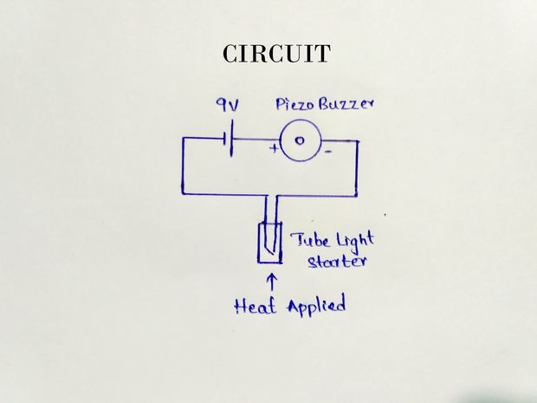

**INPUT – OUTPUT VARIATIONS**

We have seen that initially there was no buzzer sound as none of the fire was detected. When we bring a match stick near the fire switch with a time lag of 5-10 seconds the buzzer starts giving sound as the fire is detected and the circuit is completed by the action of bimetallic strip. When we remove the burning match stick away from switch, the buzzer continues to give the sound for some time due to action of capacitor and time is required by switch to return to room temperature.

**LIMITATIONS OF THE PROJECT**

• The amount of “smoke” present may be insufficient to alarm smoke detectors. Smoke detectors are designed to alarm at various levels of smoke density. If such density levels are not created by a developing fire at the location of detectors, the detectors will not go into alarm.

• Smoke detectors, even when working properly, have sensing limitations. Detectors that have photoelectronic sensing chambers tend to detect smoldering fires better than flaming fires, which have little visible smoke. Detectors that have ionizing-type sensing chambers tend to detect fast flaming fires better than smoldering fires. Because fires develop in different ways and are often unpredictable in their growth, neither type of detector is necessarily best and a given type of detector may not provide adequate warning of a fire.

• Smoke detectors are subject to false alarms and nuisance alarms. For example, a smoke detector located in or near a kitchen may go into nuisance alarm during normal operation of kitchen appliances. In addition, dusty or steamy environments may cause a smoke detector to falsely alarm. If the location of a smoke detector causes an abundance of false alarms or nuisance alarms, do not disconnect the smoke detector; call a professional to analyze the situation and recommend a solution.

• Smoke detectors cannot be expected to provide adequate warning of fires caused by arson, children playing with matches (especially within bedrooms), smoking in bed, violent explosions (caused by escaping gas, improper storage of flammable materials, etc.).

• System components, though designed to last many years, can fail at any time. As a precautionary measure, it is recommended that smoke detectors be checked, maintained, and replaced per manufacturer’s recommendations. • System components will not work without electrical power. If system batteries are not serviced or replaced regularly, they may not provide battery backup when AC power fails.

• Environments with high air velocity or that are dusty or dirty require more frequent maintenance.

**CONCLUSION**

A fire alarm is a device that detects the presence of fire and atmospheric changes relating to smoke. In some cases, a firm alarm is a part of a complete security system, in addition to a burglary protection system. The fire alarm operates to alert people to evacuate a location in which a fire or smoke accumulation is present. When functioning properly, a fire alarm will sound to notify people of an immediate fire emergency. Fire alarms can be found in homes, schools, churches and businesses, and function as the catalyst to saving lives. For most fire alarms, when sounded, a beep, bell or horn noise is made. This distinct sound exists to allow the notification to be heard. The fire alarm constructed by this project work is reliable at low cost.

**BIBLIOGRAPHY**

1. www.yahoo.com

2. www.scribd.com

3. www.google.com